**PROJECT PROPOSAL for**

(Group No 8)

**Project Management Plan**

**<BUS AND RAIL TICKET BOOKING SYSTEM>**

|  |  |
| --- | --- |
| **Name** | **ID** |
| **A.S.M. FAHAD HASAN** | **20-42931-1** |
| **MAHAMODA AKTER** | **20-44269-3** |
| **MAHBUB ALAM** | **20-42373-1** |
|  |  |

**Date : 09/07/2024**

**Table of Contents**

|  |  |
| --- | --- |
| **1.Introduction** | **03** |
| **2.Project management approach** | **03** |
| **3. PROJECT TITLE** | **04** |
| **4.Justification** | **04** |
| **5.Objectives and project scope** | **05** |
| **6.Overveiw (USE CASE DIAGRAM)** | **06** |
| **7.Stakeholder Analysis** | **07** |
| **8.** **MILESTONE LIST** | **07** |
| **9. Process Model to be followed** | **08** |
| **10. ESTIMATION** | **08** |
| **11. RESOURCE REQUIREMENTS** | **08** |
| **12. Risk Analysis:** | **09** |
| **13. Quality Control Plan** | **09** |
| **14. Budget** | **10** |
| **15 . conclusion** | **10** |

# Introduction:

**TODAY** is an IT company which develops Software projects. We have been providing software solutions for the past 5 years to multiple business sectors. Our company is based in Dhaka, but our services are provided worldwide. Our approach is to capture our client’s business requirements and develop various customized software to meet their business needs.

# 2.0 PROJECT MANAGEMENT APPROACH

The BUS AND RAIL Ticket Booking System will utilize a flexible project management approach. A core team with designated roles (project manager, analyst, architect, developers, tester) will manage budget, schedule, scope, and risks. Resource allocation considers project phases and dependencies. The project manager makes day-to-day decisions, while the sponsor approves major changes. Agile or Waterfall with iterations is a potential methodology to adapt to evolving needs. Regular communication and risk management plans ensure project success.

**3.0 PROJECT TITLE: BUS AND RAIL TICKET BOOKING SYSTEM**

# 4.0 JUSTIFICATION:

Ticketing systems play a vital role in helping businesses. Such as how to effectively deal with high volumes of customer support requests from a variety of communication channels. However, a huge number of organizations are still ignoring this customer service tool. This is mainly due to the lack of understanding of what a ticketing system is and how it can help a business. There are benefits to using ticketing systems software. Here is the advantage of using ticketing software.

* The platform you choose should help your team handle a higher volume of tickets per day than they could on their own. Many of the most popular systems include ticket management tools and other capabilities to improve the efficiency of your service.
* Mobile support is a must for every enterprise help desk. The top software options allow for seamless service whether the user is on a desktop or mobile device. Some also come with mobile apps.
* Tracking your ticketing statistics and data is essential to improving your performance. Your ticketing system should make it easy to order reports, and make improvements as needed.
* Finally, your ticketing software should improve the quality of your service by making it more personal.

# 5.0 OBJECTIVES :

The automated ticket system is currently maintaining the project Transport Company’s process manually which is a very time-consuming process. It deals with transport industry’s ticket booking and transport maintenance, so it becomes a very tedious job for the ticket booking transporter to look after these particulars to complete the task at right time. The bus ticket booking system not only deals with transporters owned vehicles but also takes into consideration about the other types project of system transport vehicles available with other transporters. To develop a software application that supports Specific to the project Travel Agency Automation that can solve all tedious tasks related to ticket booking in a travel agency.

* This system will lead to increase in the ticket booking efficiency of the project Staff and members of the Ticket Booking Agency with little throughput.
* This system project is made as user friendly as possible so that anyone can use it with little knowledge of system computers.
* The ticket booking project will reduce the ticket booking tedious job of system paperwork by keeping all the project details of bus ticket booking, cancelling tickets are stored in the form database in computer’s hard disk.
* Up-to-date information of the system Performance status and other enquires.
* We provide up to date information that is not possible manually.
* The objective of my project is to make easy the ticket booking project system of Ticket Booking Agency simple, reliable, user friendly, and corrective. Moreover, less time consuming as compared to manual work.

**Scope and Features**

The proposed software system aims to address the specific requirements and needs. The scope of the project includes the development of a comprehensive software solution, customized to meet the unique business processes and objectives of the client. The key features of the proposed system are as follows:

* **User Registration and Authentication:** Allow users to create accounts and authenticate themselves securely to access the ticket booking system.
* **Ticket Selection:** Provide users with the ability to choose the type of ticket they want to purchase, such as single journey tickets, round-trip tickets, or monthly passes.
* **Journey Planning:** Enable users to select their desired origin and destination stations, and provide them with information on available train schedules, routes, and fares.
* **Seat Selection:** If applicable, allow users to choose their preferred seats or seat categories, such as window seats or aisle seats.
* **Real-time Availability:** Display real-time availability of tickets for different trains, showing the number of seats or spaces remaining for each journey.
* **Payment Processing:** Facilitate secure payment transactions, supporting various payment methods such as credit cards, debit cards, or digital payment platforms.
* **Ticket Management:** Allow users to view and manage their booked tickets, including the ability to view ticket details, make changes (if applicable), or cancel tickets.
* **Notifications:** Send automated notifications to users regarding their booking status, changes in train schedules, or any other relevant updates.
* **Reporting and Analytics:** Provide administrators with comprehensive reports and analytics on ticket sales, revenue, passenger trends, and other relevant metrics for business insights and decision-making.

**6.0 Use Case Diagram:**

This is a Software Development Project Management plan for Dhaka subway system automated ticket issuing system. This system sells subway tickets. Users can select a destination and buy tickets using their valid credit cards and also by the mobile banking services for payment. After a valid transaction the ticket is issued. Users can also use a Rapid Pass like the previous metro rail system but we will change the top-up system. They are actually using the ticket Vending machine (TVM) system for top up but we will also add the mobile banking services for saving our time. We will also add a scanning system by the help of QR code, it’s actually a replacement of the punching system for entering into the train.

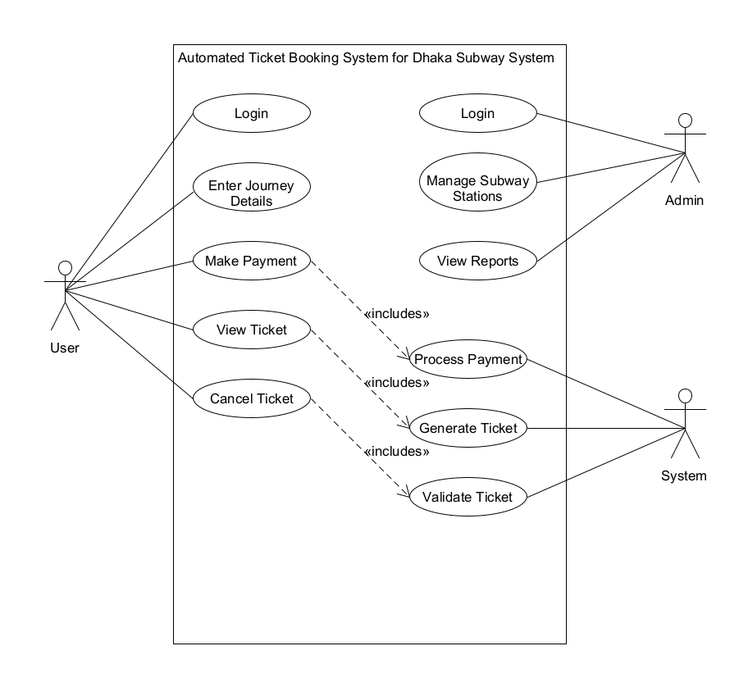

**7.0 Primary and Secondary Stakeholder:**

**Primary Stakeholders:**

* **Subway Authority:** The subway authority, such as the transportation department or agency, is a primary stakeholder as they are responsible for managing and operating the subway system. They have a vested interest in implementing an efficient ticket booking system to streamline the ticketing process and improve passenger experience.
* **Subway Passengers:** The passengers who use the subway system are primary stakeholders as they are the end-users of the ticket booking system. They rely on the system to purchase tickets conveniently, access accurate information about fares and schedules, and ensure a smooth journey.
* **Ticketing System Provider:** The company or organization that develops and provides the automated ticket booking system is a primary stakeholder. They are responsible for designing, implementing, and maintaining the system to meet the needs of the subway authority and passengers.

**Secondary Stakeholders:**

* **Subway Station Staff:** The staff members working at subway stations, such as ticketing agents or customer service representatives, are secondary stakeholders. They interact with the ticket booking system to assist passengers, address their queries, and provide support when needed.
* **Management Team:** The management team within the subway authority plays a secondary stakeholder role. They oversee the implementation and operation of the ticket booking system, monitor its performance, and make strategic decisions to enhance the system's effectiveness.
* **Maintenance and IT Support Team:** The team responsible for maintaining and providing technical support for the ticket booking system is a secondary stakeholder. They ensure the system operates smoothly, troubleshoot any technical issues, and perform regular updates and maintenance tasks.

# 

# 8.0 MILESTONE LIST

|  |  |  |
| --- | --- | --- |
| Milestone | Description | Date |
| Complete SRS | System Requirements Specification document finalized, including functional and non-functional requirements. | 09/07/24 |
| Design | system architecture and user interface design finalized. | 01/08/24 |
| Complete Coding | All application functionalities developed and integrated | 01/10/24 |
| CompleteTesting and Debugging | All functionalities thoroughly tested and bugs resolved. | 15/10/24 |
| Documents – User Guides and Installation | User guides and installation manuals completed. | 30/10/24 |

**9.0 Process Model to be followed:**

We'll leverage an Agile approach with iterative development cycles. This empowers us to adapt to evolving requirements throughout the project, unlike a rigid Waterfall model. Agile also provides faster feedback loops through user testing in each iteration, allowing us to identify and address issues early, reducing project risk. This iterative approach fosters better team collaboration and simplifies project complexity, making Agile ideal for delivering a high-quality BUS AND RAL Ticket Booking System.

**11.0: ESTIMATION:**

**Expert Judgment:**

* Leverage the experience of project team members and similar past projects to estimate effort required for each work breakdown structure (WBS) element.
* This method is quick but may lack precision, especially for innovative features.

**Three-Point Estimation:**

* Estimate optimistic, pessimistic, and most likely durations for key WBS elements.
* Calculate the weighted average to arrive at a more realistic timeframe:
  + Estimated Time = (Optimistic Time + Most Likely Time + Pessimistic Time) / 3
* This method provides a range and considers potential risks.

**12.0 RESOURCE REQUIREMENTS**

**12.1 SOFTWARE REQUIREMENTS:**

* The software will be developed using robust programming languages and frameworks, such as Java, C#, or Python, to ensure scalability, maintainability, and performance. The specific software requirements and technologies will be determined during the development phase based on the project's needs.
* **12.2 HARDWARE REQUIREMENTS :** The hardware infrastructure needed to support the software system will include servers, storage devices, and networking equipment. The exact hardware specifications will depend on factors such as the expected user load, data storage requirements, and performance objectives. A detailed hardware assessment will be conducted to determine the optimal configuration for the system

**12.3 HUMAN RESOURCE REQUIREMENTS :** The project will require a core team with expertise in various areas. Key roles include a project manager for leadership, a business analyst to bridge user needs and development, a system architect to design the technical blueprint, developers to build functionalities, and a QA engineer to ensure quality and identify bugs.

## **13.0 Risk Analysis:**

A proactive risk management plan will be implemented to identify, assess, and mitigate potential risks that could impact the BUS AND RAL Ticket Booking System project. This will involve:

* **Identifying Risks:** Brainstorming potential risks related to project scope, schedule, budget, resources, technical challenges, and external dependencies.
* **Risk Assessment:** Evaluating the likelihood and impact of each risk on the project's success.
* **Risk Mitigation:** Developing strategies to avoid, reduce the likelihood of, or minimize the impact of identified risks. This might involve contingency plans, resource allocation adjustments, or communication protocols.

**Continual Monitoring:** The risk management plan will be reviewed and updated throughout the project lifecycle to ensure ongoing relevance and effectiveness.

## **14.0 Quality Control Plan:**

The project will prioritize delivering a high-quality ticketing system. A comprehensive quality control plan will be implemented, including:

* **Definition of Quality Standards:** Establish clear quality criteria for functionalities, user interface, performance, and security.
* **Defect Management Process:** Define a process for identifying, documenting, tracking, and resolving defects throughout the development lifecycle.
* **Testing Strategy:** Implement a multi-layered testing approach, including unit testing, integration testing, system testing, and user acceptance testing (UAT) with real users.
* **Code Reviews:** Regular code reviews by experienced developers will be conducted to identify potential issues and ensure code quality.
* **Change Management:** Establish a formal process for managing changes to requirements or functionalities to minimize impact on quality and project scope.

**Continuous Improvement:** The quality control plan will be reviewed and updated as needed to ensure ongoing effectiveness.

**15.0 BUDGET:**

Our fee for the whole project from the first step to the last one will be $ [30,000]. The breakdown is provided below:

|  |  |
| --- | --- |
| SOFTWARE & HARDWARE COSTS | $ [10,000] |
| DEVELOPMENT & TESTING COSTS | $ [15,000] |
| TRAINING COSTS | $ [1,000] |
| MISCELLANEOUS COSTS | $ [4,000] |

**16.0 CONCLUSION:**

We provide a 365 days warranty, from the date of acceptance of our software proposal. During this time, if the software malfunctions, or doesn’t operate in any way, then we take the necessary steps to fix the issue and ensure that the Software operates according to the specifications. However, our services remain at your disposal for any future assistances.

**Contact us:**

You can contact us with any of the following ways:

Phone: 01717189898

E-mail: admin@TodayTicketapps.com

Website: Today Ticketapps.com

We look forward to hearing from you.

Regards,

Today Ticket Apps